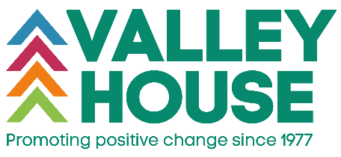

VALLEY HOUSE
INFORMATION SHEET FOR PROSPECTIVE TRUSTEES

Valley House is a Coventry based charity that has be delivering services for vulnerable individuals and families in Coventry and the surrounding areas since 1977. Our Vision is a world where there are genuine opportunities for all, where people can respond confidently to the challenges of life and our services are focused on making this happen. We provide safe and supported accommodation for female, male and families that are fleeing domestic abuse. They can live with us up to 1 year and during that time they receive one to one and group work support to help them develop the emotional and practical skills to move on in their journey. We provide a service in the community to people who have low level mental health needs, offering both practical and emotional support. We create an environment where they can overcome barriers to their health and wellbeing and see a brighter future. We have a counselling service where people can access up to 6 months free counselling to help them deal with a wide range of issues including anxiety, depression, low self-esteem, bereavement, relationships, the effects of domestic abuse. Our Nursery has been rated as “Good” by Ofsted and provides both fee paying and Government funded places.

We are currently looking to recruit 3 new trustees with specific skill sets to support us in delivering on the promises we have made in our Strategic Plan 2022-2025. These are:
1 with experience of HR
1 with experience of marketing and fundraising
1 with experience of environmental sustainability

We would be keen that one of our new trustees would be open to being our Deputy Chair at the point of joining the Board and progressing to the Chair position within 12 months of joining. As we predominately support women, we would like this to be reflected in our Board membership.

Closing date for applications: Tuesday 11 April 2023
Interviews are scheduled for Wednesday 19th and Thursday 20th April 2023, although we can be flexible if these dates are problematic.

This is a voluntary position, but reasonable expenses are reimbursed. We offer a comprehensive induction programme to support you in your role.

If you would like an informal chat or further information, please contact our CEO LJ Winterburn at lj.winterburn@valleyhouse.org.uk

Please see our website for the application pack www.valleyhouse.org.uk and further information on Valley House.

