COVENTRY DOMESTIC ABUSE NEEDS ASSESSMENT

EXECUTIVE SUMMARY

v6

COVENTRY

CONTENTS

|  |  |
| --- | --- |
| EXECUTIVE SUMMARY | 3 |
| INDEX OF RECOMMENDATIONS | 6 |
| OUR APPROACH | 7 |
| SPECIALIST DOMESTIC ABUSE SERVICES | 9 |
| OVERVIEW OF ENGAGEMENT | 10 |
| DEMOGRAPHICS | 12 |
| PREVALENCE | 16 |
| CIVIL & CRIMINAL JUSTICE SYSTEM | 18 |
| POLICE | 22 |
| MARAC | 25 |
| PERPETRATORS | 28 |
| IRIS | 33 |
| MATERNITY SERVICES | 37 |
| HEALTH | 38 |
| SPECIALIST ACCOMMODATION | 39 |
| SUPPORT NEEDS IN SPECIALIST ACCOMMODATION | 46 |
| HOUSING | 51 |
| COMMUNITY SERVICES | 58 |
| CHILDREN AND YOUNG PEOPLE | 60 |
| REFUGEES AND NEWLY ARRIVED MIGRANTS | 62 |
| MEN | 65 |

EXECUTIVE SUMMARY

# NOTE ON NEEDS ASSESSMENT

This needs assessment was completed in the Summer of 2021. The data included in the needs assessment covers the time period impacted by the COVID-19 pandemic. It is important to recognise that this period was an exceptional time and had an impact on the data for all services. The data for the period impacted by the pandemic is not reflective of previous years and this should be taken into account when viewing the information included in this report.

# INTRODUCTION

The Domestic Abuse Act 2021 places a statutory duty on Tier One local authorities to deliver support to victims of domestic abuse and their children residing within refuges and other safe accommodation, and to assess the need for accommodation-based domestic abuse support in their area for all victims or their children, including those who require highly specialist support and those who come from outside the area.

As well as assessing the specific needs mentioned in the Domestic Abuse Act relating to refuges and safe accommodation, this assessment aims to take a wider view of domestic abuse need. The assessment draws on data and information from a wide range of sources to build a picture of domestic abuse need across the whole of Coventry.

This assessment provides a shared understanding of local need to inform the development of local services and enable victims, perpetrators, their families and children to have their needs met more effectively.

**The information in this document is correct at the time of writing.**

# KEY FINDINGS

## POLICE

#### There has been an increase in domestic abuse incidents in Coventry.

There was a total of 9,280 domestic abuse incidents reported to the Police during 2020. This is a 33% increase on the previous highest number over the analysed period which was 7,000 during 2019.

#### There has been increases in various offence types where there is a domestic abuse flag – with stalking seeing the largest increase.

“Pursue Course of Conduct In Breach Of S1(1) Which Amounts To Stalking” saw an annual average of 19 incidents a month during 2016-19. There were 421 in 2020, equating to a 2145% increase.

#### By ward, Binley & Willenhall show the highest increases in incidents with a domestic abuse flag and also a high rate per 100,000 population..

Wainbody ward and Earlsdon ward both have low rates and low increases in reported incidents relative to the other wards in Coventry. Binley & Willenhall had one of the highest increases and shows the highest rate per 100,000 population.

#### 35% of the victims during 2016 to 2020 were repeat victims.

8% of the victims during this period appeared 5 or more times.

#### There has been an increase in male victims.

Males accounted for 26% of victims recorded in 2020, which is a 6 percentage point increase on the 20% recorded in 2016.

#### There has been a shift in the age structure of the victims.

The 55+ age group has increased from 9% of the total number of victims in 2016 to 11% in 2020. Conversely, the 18-24 age group has seen a decrease from 22% to 18%.

## MARAC

#### There has been an increase in referrals to MARAC in 12 months to June 2021.

The 613 referrals in the 12 months to June 2021 is the highest in any 12-month period. There has been a 69% increase over the past 5 years. This is similar to the West Midlands.

#### 45% of the referrals to MARAC in the 12 months to June 2021 were repeat cases.

This is slightly higher than the previous 2 years.

#### In the past 2 years there has been an increase in IDVA and partnership referrals.

Partnership referrals include mental health, health services, and ‘other’.

## PERPETRATOR

#### In Coventry, there is one local authority commissioned perpetrator programme; Choose2Change provided by Relate.

There were high attrition rates in the Choose2Change Domestic Abuse Programme. The programme is in-depth but difficult for people to complete.

## IRIS

#### IRIS (Identification and Referral to Improve Safety) to improve Primary Care awareness of domestic abuse and support to Victims was launched in June 2018. In the first full year of service delivery, only 50% of the GP Practices were able to participate in IRIS as only one Advocate Educator resource was commissioned.

2020-21 saw the recruitment of a second Advocate Educator and an increase in training sessions. Subsequently, there has been a higher volume of referrals with only 4 Practices not currently signed up.

#### There appears to be a moderate to fairly-strong correlation between the number of training sessions delivered by postcode and the number of referrals received.

The CV4 and CV5 postcodes had a low number of training sessions, which may have impacted on the number of referrals. CV5 has since increased training session with the numbers of referrals increasing possibly as a result. CV4 is potentially an area of unmet need.

## SAFE ACCOMMODATION

#### The Domestic Abuse Act places a duty on local authorities to assess the need for support and prepare strategies to provide support for victims who reside in relevant accommodation (‘safe accommodation’).

#### Domestic Abuse Act guidance describes a variety of different types of safe accommodation:

Refuge accommodation, specialist safe accommodation, dispersed accommodation, safe self-contained accommodation, safe self-contained ‘semi-independent’ accommodation, sanctuary schemes, move-on/ second stage accommodation, other forms of domestic abuse emergency accommodation. Bed and breakfast accommodation is not considered as relevant, safe accommodation.

#### In Coventry there is the following specialist accommodation provision: Valley House (LA funding) – 54 units + 20 units (temporary MHCLG and COVID funding), Coventry Haven (Independent) – 17 units, Panahghar (Independent) – 18 units.

The recommended number of refuge spaces for Coventry (using the Council of Europe formula) is 35 with the actual number commissioned exceeding this by 19 spaces.

#### Domestic Abuse Act guidance describes domestic abuse support as accommodation support, childrens’ support, housing-related support, and advice service.

Data indicates that there are a range of needs present amongst residents in refuges including mental health, legal support needs, and housing support needs.

#### In Haven, 8% of referrals in 2020-21 were rejected due to capacity.

Of the 126 referred to Haven during 2020-21, 39 (31%) were accommodated. 10 (8%) were not accommodated for due to no capacity. The COVID-19 pandemic impacted this figure as Haven did not advertise spaces and instead kept them available for Coventry homeless.

#### 30% of referrals to Panahghar were rejected due to lack of capacity.

Of the 79 referred to Panahghar during 2020-21, 48 (61%) were accommodated. 24 (30%) were not accommodated for due to no capacity.

#### Only 2 (1%) of the 241 referrals to Valley House were rejected due to a lack of space.

#### Current demand is short by 36 spaces per year.

This does not take into account the impact of Covid-19, and peaks and troughs during the year.

## COMMUNITY SERVICES

#### Relate, Panahghar and Coventry Haven are commissioned to provide services to those impacted by domestic abuse living in the community.

Services include community outreach, IDVA support, group work, perpetrator services, children’s specific support, a domestic abuse helpline, and the early intervention project.

INDEX OF RECOMMENDATIONS

|  |  |  |  |
| --- | --- | --- | --- |
| Key Finding | Page | Title | Summary |
| 1 | 19 | Specialist Court IDVA | Support need in relation to support with the Criminal and Civil Justice System (C & CJS). |
| 2 | 20 | CJS Knowledge Gap | A knowledge gap amongst practitioners relating to the Criminal Justice Service response and available specialist support |
| 3 | 21 | Children And Family Courts | Gaps in the monitoring of Children and Family Court Advisory and Support Service (CAFCASS) decisions |
| 4 | 30 | Perpetrator Programmes | Lack in offering for high-risk perpetrators. |
| 5 | 31 | Perpetrator Referrals | There were high attrition rates in the Choose to Change Domestic Abuse Programme. The programme is in-depth but difficult for participants to complete. |
| 6 | 32 | GP & IRIS Perpetrator Pathway | Data from the IRIS programme indicated that perpetrators did disclose abuse to their GP. |
| 7 | 36 | Iris Training | The participation of GPs in training has a strong correlation with referrals. |
| 8 | 38 | Barriers To Registering for Health Services | Healthcare settings to assess how ‘Domestic Abuse friendly’ their registration systems are and make adjustments based on specialist advice. |
| 9 | 43 | Refuge Spaces | Supply and demand of refuge spaces in Coventry. |
| 10 | 44 | Temporary Accommodation for Victims of DA | Need for floating support to meet needs of those in TA. |
| 11 | 45 | Target Hardening | Consider expanding scheme. |
| 12 | 48 | Anxiety and Trauma | Exploration of a psychologically informed model within refuges. |
| 13 | 49 | Children and Young People | Review children’s support in refuges. |
| 14 | 50 | Housing Support | Training for housing staff and linked professionals on the impact, risks and interventions for families affected by domestic violence |
| 15 | 52 | Role of Housing Keyworker | Importance of keyworkers to the housing process. |
| 16 | 53 | Housing Managers | Consider adopting a Whole Housing Approach to raise awareness across the partnership of quality assurance standards and safe minimum practice. |
| 17 | 54 | Housing Officer | Addressing fears of those refusing housing offers. |
| 18 | 55 | Limited Housing Stock | Limited availability of housing for larger families requires further exploration. |
| 19 | 56 | Private Housing | Service users being directed towards private housing require a guarantor, which refuge residents tend not to be able to provide. |
| 20 | 57 | Furnishing Properties | Setting up of a fund to help with moving/furnishing costs. |
| 21 | 61 | Specialist Childrens’ Support | Explore widening the specialist children’s service response to meet the needs of all children, not just those with a Social Care involvement. |
| 22 | 63 | No Recourse to Public Fund | Further explore the particular needs and challenges for this population in partnership with specialist services to identify practical solutions. |
| 23 | 64 | Translators | Requirement for additional support in this area. |

OUR APPROACH

|  |  |
| --- | --- |
| SURVEYS | FOCUS GROUPS |
| Clipboard with solid fill  HOUSING  CHILDREN AND YOUNG PEOPLE  HEALTH  SUPPORT SERVICES  PROTECTED CHARACTERISTICS  COMPLEX NEEDS  CRIMINAL JUSTICE  SURVIVOR SURVEYS COMPLETED  71  PRACTITIONER SURVEYS COMPLETED  51 | Multiple Groups Completed  VALLEY HOUSE  COVENTRY HAVEN  PANAHGHAR  SURVIVORS  YOUNG PEOPLE  STAFF  POSITIVE YOUTH FOUNDATION |
| DATA ANALYSIS | 1-2-1 INTERVIEWS |
| Statistics with solid fill  Multiple Data Sources Analysed | Questions outline  30+  1-2-1 INTERVIEWS COMPLETED WITH KEY STAKEHOLDERS |

* Strategy Addendums cover the provision of accommodation-based support for victims and children.
* Strategy Addendums cover the impact of COVID-19.

The Strategy Addendums are informed by the needs assessment

* Includes key findings
* Includes recommendations
* Includes chapter summaries
* Includes full analysis.
* Includes all the engagement work
* Includes full literature review



COVENTRY DOMESTIC ABUSE STRATEGY

ADDENDUMS

v1

Key points from full assessment included in executive summary



COVENTRY DOMESTIC ABUSE NEEDS ASSESSMENT

EXECUTIVE SUMMARY

v1



COVENTRY DOMESTIC ABUSE NEEDS ASSESSMENT

FULL DOCUMENT

v1

|  |
| --- |
| WISH |
| Support service for children and young people affected by domestic abuse. |
| Choose 2 Change |
| Domestic abuse perpetrator programme. |

|  |
| --- |
| Safe to Talk |
| Helpline, website, social media |
| Refuge |
| 18 units |
| Community Outreach |
| Standard and medium risk  Support and training |
| Outreach and Aftercare |
| Group work and 1-2-1 |
| Sanctuary Scheme |
| Target Hardening |
| IRIS Support |
| Advocate Educators  Training to GPs |

|  |
| --- |
| Refuge |
| 18 units (BME Specialist) |
| IDVA |
| BME Specialist |
| Community Outreach |
| Work with standard and medium risk.  Offering support, training, and awareness. |

|  |
| --- |
| Early Intervention Project (Haven & Panahghar) |
| Embedded with police  Medium and low risk cases |

|  |
| --- |
| Supported Accommodation |
| 54 units of supported accommodation |

SPECIALIST DOMESTIC SERVICES

OVERVIEW OF ENGAGEMENT

|  |  |  |
| --- | --- | --- |
| Open hand with plant with solid fillSUPPORT SERVICES | Working Well   * Provision of advocacy support * Prevention advice   Area for Development   * Counselling and therapy | “When I was assigned a key worker, she appeared to listen (over the telephone) without judgement and she provided me with support.”  Survivor, 35-44  “The key workers are great at supporting my daughter’s mental health, 11 years ago she was diagnosed with BPD ... with their help she has stayed strong.”  Survivor, 55-64 |
| Safe with solid fillPROTECTED CHARACTERISTICS | Area for Development   * Translators   Potential Knowledge Gap   * Faith Service * Interpreters for hard of hearing * Dedicated support for LGBTQ+ |  |
| Iceberg with solid fillCOMPLEX NEEDS | Working Well   * Drug and alcohol advice and support   Area for Development   * Mental health advice and support | “On an initial appointment with Coventry Haven, they identified that I could possibly be suffering from PTSD. I was then diagnosed by a doctor. Had this not been suggested to me, I wouldn't have had this diagnosis and no one over the years had identified this in me, yet when looking back at what was happening to me, it was completely obvious that that was behind the majority of my illness. I then was able to access the counselling services that have been absolutely imperative in my recovery.  Survivor, 35-44 |
| Scales of justice with solid fillCOURT | Potential Knowledge Gap   * Support to attend court hearings * Court Orders & Immigration law * Advice on Legal Matters | “I wasn’t advised as to the terms of the non-molestation. I was unable to contact anyone via phone or email and had to wait on paperwork arriving. The order was given for 6 months, not the 12 requested, as explained, there were danger dates where it’s anticipated he will attempt contact.”  Survivor 35-44 |
| House with solid fillHOUSING | Working Well   * Temporary/ refuge accommodation | “Coventry homelessness team did not seem to understand abuse and victim blame”  Survivor, 35-44 |
| Child with balloon with solid fillCYP | Working Well   * Info on impacts of DA on children   Potential Knowledge Gap   * Child advocacy   Area for Development   * Counselling * Trauma support for children | “Support to children was unable to be offered at school. Family are no longer able to make the referral and can only come from social care if open to services.”  Survivor, 35-44 |
| Medical with solid fillHEALTH | Working Well   * Advice / support on managing health issues * Advice on local GP's and Dentists | “I had a support plan which included an area around my health, and I hadn’t appreciated how much of my poor health was because of how I was living and being abused. I was registered straight away at the doctors and supported in being able to tell him what I was feeling about my concerns. I had been worrying about my sexual health and my worker helped me to book an appointment to get all of the tests I needed.”  Survivor 25-34 |

DEMOGRAPHICS

# KEY FINDINGS

**THE POPULATION HAS SEEN YEAR-ON-YEAR INCREASES**

* The latest available ONS Mid-Year estimates provide a figure of 371,521 population for Coventry.
* Since 2014, the population has grown on average 7,300 per year; however recent years has seen slower growth. The increase is due to natural change and international migration.
* Based on population size, Coventry is the ninth largest city in England.
* The split between males and females is relatively even.

*Population of Coventry by Ward; change between 2014 to 2019.*

**WARD ANALYSIS**

* Coventry is made up of 18 wards.
* The population by ward ranges from 15,486 in Wainbody to 39,720 in St Michael’s.
* The chart shows the change in population by ward since 2014 and highlights the significant growth in population in the St Michael’s ward. St Michael’s is home to the university and the population change reflects the increase in the student population.



**THERE ARE VARIANCES IN THE AGE STRUCTURE BETWEEN WARDS**

* Below shows the population of Coventry by ward and by age bands. The age bands reflect those recorded in the Crime Survey of England and Wales (CSEW).

**THERE IS SIGNIFICANT POLARISATION OF DEPRIVATION BETWEEN THE WARDS**

* It is estimated that 19% of the neighbourhoods in Coventry are amongst the 10% most deprived in the Country.
* The following map shows the IMD decile by ward, where 1 is the most deprived (most deprived 10%) and 10 is the least. Note that the calculations are the average of the Lower Super Output Areas in the Ward as IMD is not produced at Ward level.
* Combining the IMD along with other factors such as age may help to understand prevalence. For example, Bablake Ward has a lower expected prevalence based on age, and in addition, low deprivation.



# Map Description automatically generatedRECOMMENDATIONS

**NO RECOMMENDATIONS**

* No recommendations relating to demographics.

PREVALENCE

# KEY FINDING

**EXPECTED PREVALENCE - OVERVIEW**

* Applying the domestic abuse prevalence by age from the CSEW gives a figure of 15,793 for Coventry. The actual number of crime incidents recorded was 9,280. The expected number is based only on age and does not take into account other factors such as ethnicity and deprivation.
* Below shows the expected prevalence and the actual number of DV incidents as a rate per 100,000 population.

|  |  |  |
| --- | --- | --- |
| EXPECTED NUMBER OF DOMESTIC ABUSE INCIDENTS | RECORDED NUMBER OF DOMESTIC ABUSE INCIDENTS | UNIQUE NUMBER OF VICTIMS |
| 15,793 | 9,280 | 5,579 |

**EXPECTED PREVALENCE – BY AGE**

* The following table shows the expected and actual prevalence of domestic abuse by age group.
* The expected prevalence is taken from the Crime Survey of England & Wales (CSEW) with the actual prevalence taken from police data and covers all domestic abuse flagged incidents.

|  |  |  |  |  |  |  |
| --- | --- | --- | --- | --- | --- | --- |
| Prevalence of domestic abuse in the last year among adults aged 16 to 74 – Any Domestic Abuse | Men | | Women | | All | |
| Expected | Actual | Expected | Actual | Expected | Actual |
| Under 16 | - | 0.0 | - | 0.1 | - | 0.0 |
| 16-19 | 5.3 | 1.0 | 14.0 | 3.1 | 9.5 | 2.0 |
| 20-24 | 4.9 | 0.7 | 10.0 | 3.2 | 7.4 | 1.9 |
| 25-34 | 4.2 | 1.1 | 7.7 | 4.0 | 5.9 | 2.5 |
| 35-44 | 4.2 | 1.4 | 6.9 | 4.5 | 5.6 | 2.9 |
| 45-54 | 3.7 | 1.2 | 7.7 | 2.6 | 5.7 | 1.9 |
| 55-59 | 2.5 | 0.8 | 6.5 | 1.7 | 4.6 | 1.2 |
| 60-74 | 1.9 | 0.5 | 4.4 | 1.0 | 3.2 | 0.7 |
| 75+ | - | 0.3 | - | 0.4 | - | 0.4 |
| ALL ADULTS | 3.6 | 0.7 | 7.3 | 2.3 | 5.5 | 1.5 |

**EXPECTED PREVALENCE – BY WARD**

* Below shows the expected prevalence of DV incidents as a rate per 100,000 population.

* Total DV incidents in 2020; rate per 100,000 population.

****CIVIL & CRIMINAL JUSTICE SYSTEM

# KEY FINDINGS



**SPECIALIST ADVOCACY**

* Analysis of local refuge/ supported accommodation data shows that there is a support need in relation to support within the Criminal Justice System.
* There was no Specialist Court IDVA based in Coventry.
* Specialist IDVAs can help navigate the court system and advocate for the victim amongst other roles.

**SAFE LIVES REPORT**

* The Safe Lives Report ‘*Understanding court support for victims of domestic abuse*’ makes a number of recommendations in relation to court processes:
* Need for urgent action on court backlogs and increased long-term investment.
* Recognising the role of IDVAs as an integral part of court systems.
* Realising ‘trauma-informed’ courts and cultural change training for all professionals.



**COURT PROCESSES**

* The Women’s Aid Survivor Survey highlighted the lack of understanding that survivors had of court processes.
* There is an increased risk to the survivor if there is a delay in communication or no communication of court results to them.

**COVID-19**

* The pandemic has impacted the length of cases from reporting through to court.
* Between January and November 2020, in Coventry, there were 89 incidents of domestic abuse per 10,000 residents. This was a 45% increase compared to 2019.
* This places additional strains on victims – “life on hold”. Likely to be increased victim attrition from court processes.



**CAFCASS**

* Feedback from practitioners show that there are sometimes gaps in the monitoring of CAFCASS decisions.

# RECOMMENDATIONS

The chart shows the proportion of residents in Valley House in 2020 who required support with legal issues.

**KEY FINDING 1 – COURT IDVA**

* Analysis of local refuge data shows that there is a support need in relation to support with the Criminal and Civil Justice System (C & CJS).
* The Women’s Aid Survivor Survey highlighted the lack of understanding that survivors had of court processes and the complexity and risks for survivors and their children while engaging with the C & CJS.

**IMPACT**

* There is an escalation in risk, fear, and uncertainty through engagement with the C & CJS which requires specialist advice, support and risk reduction interventions, including coordinated multiagency working.
* Interventions and advice will vary depending on context, needs and risk factors. There is a possibility that perpetrators will use C & CJS and credible professionals to perpetuate abuse[[1]](https://www.gov.uk/government/news/major-overhaul-of-family-courts-to-protect-domestic-abuse-victims).

**RECOMMENDATION**

* Explore the possibility of specialist Court IDVAs and identify the logistical or systemic barriers that heighten risk and safety consequences for engagement with C & CJS.
* Map out the access points for specialist support & legal advice for help-seeking survivors and their children.

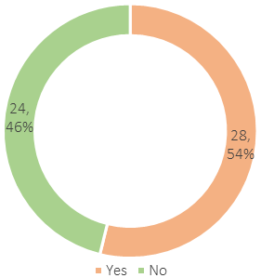

“I wasn’t advised as to the terms of the non-molestation [order]. I was unable to contact anyone via phone or email and had to wait on paperwork arriving.”

“The order was given for 6 months, not the 12 requested, as explained, there were danger dates where it’s anticipated he will attempt contact. And after his ex-wife had the same order previously (for 12 months due to physical abuse)”

Survivor, 35-44

**KEY FINDING 2 – KNOWLEDGE GAP**

* The Coventry practitioners survey highlighted that there was a knowledge gap amongst practitioners relating to the Criminal Justice Service response and available specialist support.

**IMPACT**

* Staff are less likely to proactively enable disclosures, make timely or appropriate referrals, recognise the need for coordinated working or early intervention due to their knowledge gap.
* Individuals and families in crisis are more likely to be identified but risks and safety planning in relation to C & CJS may be limited.

**RECOMMENDATION**

* Ongoing Multi Agency Training to teams and lead professionals on the nature and impact of domestic abuse, and appropriate safe interventions.
* Explore ways of embedding domestic abuse awareness into strategic leadership, organisational development and core business across Multi Agency practice.

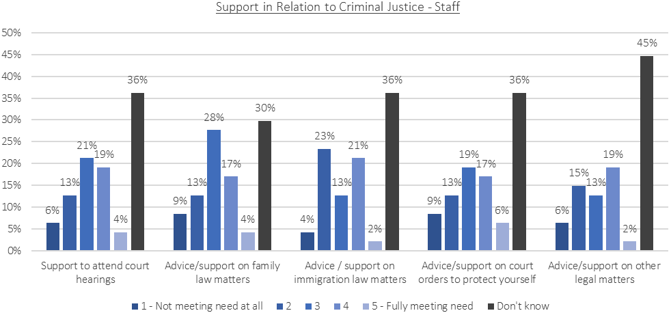

“I don't have a good enough understanding of what is happening in these areas to fully comment.”

Childrens’ Service Practitioner

“We need more awareness of this service for all professionals”

Substance Misuse Practitioner

**KEY FINDING 3 – CHILDREN AND FAMILY COURTS**

* Feedback from practitioners show that there are on occasions, gaps in the monitoring of Children and Family Court Advisory and Support Service (CAFCASS) decisions. This relates to CAFCASS decisions stating that there should be no child contact with a perpetrator.

“Where is the monitoring and guidance given by the courts and social care? In this case, dad is getting access to his children even though CAFCASS recommended there should be no contact. Dad obtained contact via solicitor and the civil courts.”

Specialist Accommodation Practitioner

**IMPACT**

* Gaps in monitoring will enhance and escalate risks to children and the non-abusing parent. These risks are amplified when there are multiple abusers and the survivor, and their children are being coercively controlled.

**RECOMMENDATION**

* Risk management training to professionals supporting families engaging with C & CJS with clear referral routes to specialist services and the need for coordinated case management to support safe interventions.

POLICE

# KEY FINDINGS

**-- TECHNICAL NOTES --**

* The analysis is based on raw data provided by the Partnership Intelligence Liaison Team.
* The chapter is based on the initial analysis, and further refinement is recommended. For example, offence types are filtered out to include selected incident types.
* The analysis below uses all incident types which includes non-crimes such as “MARAC DA REFERRAL- NON-CRIME” and “DOMESTIC VIOLENCE DISCLOSURE REQUEST (CLARE'S LAW) - NON CRIME”.
* Further analysis has been undertaken removing CUC Expansion “Non-Crime”. This is in the full document.

**NUMBER OF REPORTS**

* There was a total of 9,280 domestic abuse incidents reported to the Police during 2020. This is a 33% increase on the previous highest number over the analysed period which was 7,000 during 2019.
* The average number between 2016 to 2019 was 6,326. The numbers in 2020 represents a 47% increase.
* The analysis by month shows that it was from May onwards which saw the highest increase on the average.

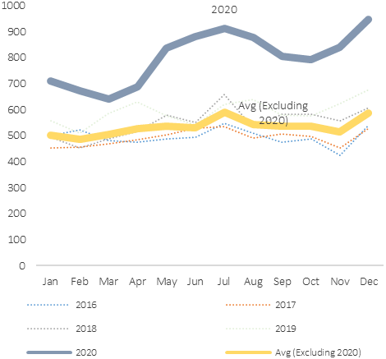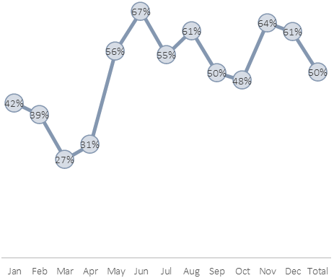

% change: 2020 vs 2016-2019 average.

# of incidents: 2020 vs 2016-2019 average.

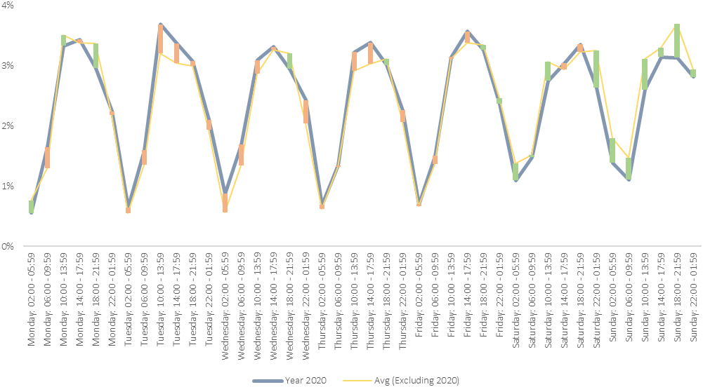

Fewer calls (as % of total) during the weekend in 2020.

**TEMPORAL ANALYSIS**

* The following chart shows the distribution of calls to the Police (not necessarily incident time) by day and time. The chart shows 2020 compared against the 2016-19 average.
* The red and green line shows the variance of the 2020 distribution away from the 2016-19 average.
* The 2016-19 average shows more calls during the evenings of the weekend; however, the 2020 data shows more of an even distribution. This is linked to the impact of lockdown.

**CERTAIN OFFENCE TYPES REPORT HIGHER INCREASES THAN OTHERS [INCLUDING NON CRIME]**

* “Domestic Violence Incident - Non-Crime” accounted for 37% of the calls in 2020, and has seen increases on 2019 (18%) and the 2016-19 average (9%).
* In terms of actual increases in incident type, common assault saw an increase of 790 to 1,390 in 2020 in comparison to the 2016-19 average. This represents an increase of 132%.
* “Pursue Course of Conduct In Breach Of S1(1) Which Amounts To Stalking” saw an annual average of 19 incidents a month during 2016-19. There were 421 in 2020 equating to a 2145% increase. The % change in recorded stalking is due to changes in the recording guidelines in 2020.

|  |  |  |  |  |  |  |  |  |  |  |  |
| --- | --- | --- | --- | --- | --- | --- | --- | --- | --- | --- | --- |
| Offence | 2016 | 2017 | 2018 | 2019 | 2020 | Avg (2016-19) | Change Against 2019: # | Change Against 2019: % | Change Against Avg (2016-19): # | Change Against Avg (2016-19): % | 2020 % of Total |
| DOMESTIC VIOLENCE INCIDENT - NON-CRIME | 3486 | 3374 | 3265 | 3032 | 3587 | 3289 | 555 | 18% | 298 | 9% | 37% |
| COMMON ASSAULT | 444 | 451 | 625 | 881 | 1390 | 600 | 509 | 58% | 790 | 132% | 14% |
| ASSAULT OCCASION ABH | 748 | 724 | 854 | 943 | 1038 | 817 | 95 | 10% | 221 | 27% | 11% |
| PURSUE COURSE OF CONDUCT IN BREACH OF S1(1) WHICH AMOUNTS TO STALKING | 4 | 17 | 23 | 31 | 421 | 19 | 390 | 1258% | 402 | 2145% | 4% |
| SEND COMMUNICATION/ARTICLE CONVEYING A THREATENING MESSAGE | 93 | 100 | 151 | 194 | 320 | 135 | 126 | 65% | 186 | 138% | 3% |

MARAC

# KEY FINDINGS

**REFERRAL SOURCES**

* Referrals from the police has historically accounted for a high percentage of the total.
* The last few years has seen a decrease in the percentage of police referrals and increase in IDVA and partnership referrals.
* Partnership referrals include mental health, health services, and other.
* In comparison to the other local authorities in West Midlands, as a rate of the total, Coventry shows high rates of referrals from IDVA and from other sources who are not the Police.

**REPEAT CASES**

* 45% of the referrals in the 12 months to June 2021 is slightly higher than the previous 2 years.
* The 45% rate is similar to the majority of the other local authorities in West Midlands.

**SAFELIVES ESTIMATE**

* The SafeLives estimates 576 cases in Coventry. The actual number was slightly higher at 613.
* The 613 rate is lower than 4 out of the 6 other local authorities in West Midlands.

**REFERRAL NUMBERS**

* The 613 referrals in the 12 months to June 2021 is the highest in any 12-month period.
* There has been a 69% increase over the past 5 years. This is similar to the West Midlands.

**BLACK, ASIAN AND MINORITY ETHNIC**

* The percentage of MARAC referrals including a Black, Asian and Minority Ethnic victim / perpetrator has been between 22-28% of the total over the last 3 years.
* Using the 2011 census as a comparator, the chart shows a proportionate figure of MARAC referrals against this. For example, 26% of the population in the 2011 census were Black, Asian and Minority Ethnic, with 22% of MARAC referrals recorded with Black, Asian and Minority Ethnic victim perpetrator resulting a calculation of 0.9. With other factors being equal, this rate suggests that roughly a representative number of Black, Asian and Minority Ethnic referrals are being received.
* It is possible that the Black, Asian and Minority Ethnic population of Coventry has increased since the 2011 census. This information will have to be revisited once the latest census data is released.

**CHILDREN**

* For the 12 months to June 2021, there were 661 children were associated with the cases discussed.
* This equates to an average of 1.1 children per case discussed. This is similar to the previous year and to the other local authorities in Coventry.

**LGBT**

* The number of cases for LGBT relationships has never exceeded more than 5 in any 12-month period. This is less than 1% of the total cases. This rate is similar to West Midlands.

**DISABILITY**

* The percentage of MARAC referrals with a disability identified has increased from 0% for the 12 months to June 2017 to 4% for the 12 months to June 2021. This equates to 23 referrals for the 12 months to June 2021.
* Across the West Midlands, the rate ranges from 2% in Birmingham and in Sandwell to 6% in Solihull.

**MALE VICTIMS**

* There has been a decrease in the number and rate of male victims, from 3% (14) for the 12 months to June 2019 to 1% (6) for the 12 months to June 2021.
* The 1% rate is one of the lowest across the West Midlands area.

**VICTIMS AGED 16-17**

* Excluding the 12 months to June 2017, the number of victims aged 16-17 is on average below 10 a year. This equates to less than 1% of the total referrals. This is comparable to the West Midlands average.

**THE NUMBER OF MARAC IDVAS (3), IS LOWER THAN THE SAFELIVES ESTIMATE**

* Safe Lives recommends that IDVAs cover no more than 100 cases per year which means around 5.77 full time equivalent (FTE) IDVAs are needed to cope with the number of cases heard at MARAC in Coventry.
* In Coventry there are 7 FTEs with a proposed 3 extra currently in process. Of these IDVAs, only 3 are MARAC IDVAs, the other IDVAs have different responsibilities.

# RECOMMENDATIONS

**NO RECOMMENDATIONS**

* No recommendations relating to MARAC.

PERPETRATORS

# KEY FINDINGS

|  |  |  |  |  |
| --- | --- | --- | --- | --- |
| **PROGRAMME** | DOMESTIC VIOLENCE PERPETRATOR PROGRAMME | BUILDING BETTER RELATIONSHIPS | DRIVE PROGRAMME | CHOOSE 2 CHANGE PROGRAMME |
| **PERPETRATOR RISK LEVEL** | MODERATE AND STANDARD RISK | MEDIUM TO HIGH RISK | HIGH RISK | LOW TO MEDIUM RISK |
| **TYPE** | NON-COURT MANDATED | COURT MANDATED | NON-COURT MANDATED | NON-COURT MANDATED |
| **AVAILABLE IN COVENTRY** | Close with solid fill | Checkmark with solid fill | Close with solid fill | Checkmark with solid fill |



**AVAILABLE COURSES**

* The following perpetrator programmes are available in Coventry:
* Choose2Change Programme (Relate)
  + Local authority commissioned.
  + Primary reason for the programme is victim and child safety.
* Building Better Relationships Programme (Probation)
  + Court mandated programme
* CAFCASS (My Time Richmond Fellowship)
  + A service commissioned by CAFCASS, for court ordered and directed Domestic Abuse Perpetrator Programmes. Referrals are accepted exclusively from CAFCASS Family Court Advisors.

**DOMESTIC VIOLENCE PERPETRATOR PROGRAMME**

* Previously, the domestic violence perpetrator programme was offered to residents of Coventry.
* The programme was not delivered within Coventry, which was a barrier to perpetrators attending.
* The course was aimed at medium to high-risk perpetrators (non-court mandated); there is now a gap in this area.
* The programme was commissioned by the PCC but has now ceased.

**CARA AND ALCOHOL & DA INTERVENTION SCHEME**

* The CARA (Cautions and Relationship Abuse) programme is run in Coventry. The programme consists of 2 workshops and is referred into via the police.
* Cranstoun run an alcohol related violence scheme that is not specifically aimed at perpetrators of domestic abuse.

**EXPERIENCE OF SURVIVORS**

* Practitioners working in the areas of early identification and prevention highlighted that the system seems to be more severe on the survivor compared to the perpetrator.
* There is a lot of pressure put on the survivor in terms of attending services and domestic abuse courses. Particularly in relation to child protection plans.

**REFERRALS**

* There were high attrition rates in the Choose2Change Domestic Abuse Programme. The programme is in-depth but difficult for people to complete.
* In 2020, there were 69 referrals, of which 28 had a full assessment.
* The reasons for this include inappropriate referrals being made and perpetrators dropping out of the process before an assessment is completed.
* Feedback from practitioners was that it was hard to get people they were working with to engage in the non-court ordered perpetrator course.
* Most of the referrals to the Choose2Change programme came from Children Social Care.
* The Choose to Change programme is for perpetrators of intimate partner violence and does not relate to familial abuse.

**COVID-19**

* Feedback from probation was that there was a backlog of people waiting to attend the probation run perpetrator courses.
* During the COVID-19 pandemic, in person courses were not running.
* There is a backlog of cases coming through Magistrates and Crown Courts.



# RECOMMENDATIONS

**KEY FINDING 4 – AVAILABILITY OF PERPETRATOR PROGRAMMES**

* In Coventry, there is a local authority commissioned perpetrator programme; the Choose 2Change Programme has a preventative focus and is predominantly for perpetrators at a low to medium risk.
* The PCC commissioned Domestic Violence Perpetrator Programme is not run in Coventry.
* There are no non-court mandated perpetrator programmes for high-risk perpetrators in Coventry.

**IMPACT**

* There are a cohort of perpetrators who are not eligible for the Choose 2 Change programme who are not able to receive any interventions aimed at addressing their perpetrating behaviour.

**RECOMMENDATION**

* Gaps in the offering for high-risk perpetrators should be addressed.

“Tackling the perpetrator and focussing on changing their behaviour should be given as much weight as supporting the victims or we will still be in the same position in 20 years’ time.”

Coventry City Council, Programme Manager

**KEY FINDING 5 – REFERRALS**

* There were high attrition rates in the Choose2Change Domestic Abuse Programme. The programme is in-depth and challenging.
* In 2020, there were 69 referrals, of which 28 had a full assessment.
* Feedback from practitioners was that it was hard to get people they were working with to engage in non-court ordered perpetrator courses.

**IMPACT**

* A high proportion of perpetrators did not complete the programme and therefore have not appropriately addressed their behaviour.
* Those who could potentially benefit from interventions were not accessing services.
* Appropriate interventions are dependent on context, severity, and willingness to engage. Professionals working with perpetrators or referring perpetrators to services may need awareness training.

**RECOMMENDATION**

* Training regarding ‘what works’ when addressing perpetrator behaviour, including motivational interviews for practitioners who work directly with families[[2]](http://driveproject.org.uk/about/research-evaluation/).
* Consider expanding the definition of intervention ‘success’ and for the use of women/partner reports in evaluation.

**KEY FINDING 6 – GP AND IRIS PERPETRATOR PATHWAY**

* Data from the IRIS programme indicated that on occasion, perpetrators did disclose abuse to their GP.

**IMPACT**

* More perpetrators could be offered help through the GP route.

**RECOMMENDATION**

* Perpetrator work already included in the IRIS training package are reinforced and promoted with GPs.

IRIS

# KEY FINDINGS

**OVERVIEW**

* ‘The IRIS programme started in Coventry in June 2018. Coventry and Warwickshire CCG directly commission Coventry Haven to deliver the programme.
* There are still 4 practices who have not signed up to the IRIS training.
* GPs refer both survivors and perpetrators to the IRIS programme.
* There are plans to further develop the IRIS programme to include dentistry, pharmacies, and sexual health services.

**TRAINING AND REFERRALS**

* There were relatively low number of training sessions and referrals in 2019-20.
* 2020-21 saw an increase in training sessions, and subsequently high number of referrals.

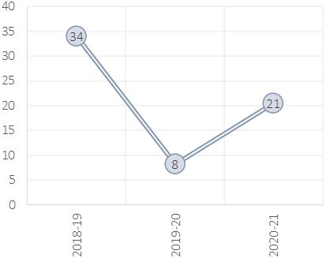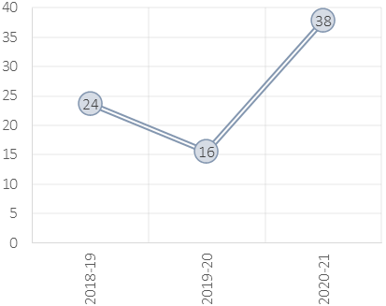

Training: Quarterly Average

Referrals: Quarterly Average

**GENDER**

* Females accounted for 93% of the referrals, with all except 1 recorded as victims.
* Males accounted for 7% of the referrals, with 5% recorded as victims, and 2% as perpetrators.
* 3 of the 6 males who disclosed as perpetrators did so in the analysed time period during Covid-19.

**AGE**

* There has been a change in age structure of those referred.
* The 55+ age group has seen a decrease as a percentage of the total.
* A high percentage are from the 26-40 age group; however, this rate has been decreasing.
* The 18-25 and 40-55 age groups both report increases.

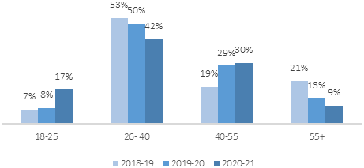

Change in ages of referral; % of total.

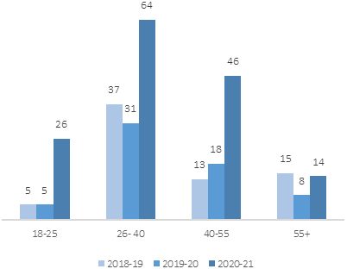

Change in ages of referral; actual count.

**CORRELATION BETWEEN “SOCIAL CLASS” AND NUMBER OF REFERRALS**

* The geographical analysis by “social class” and number of referrals shows a level of correlation.
* This however could be linked to the more deprived areas being targeted with more training sessions.

**ETHNICITY**

* The increase in the number of referrals has meant all ethnic groups show an increase, however certain groups report a higher increase.

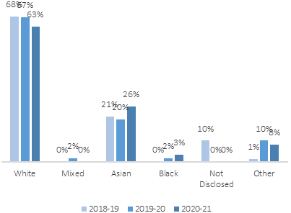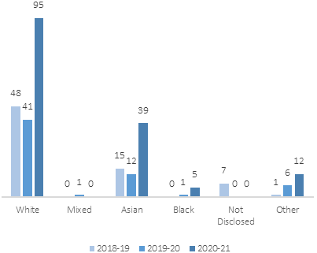

Change in ethnicity of referrals; % of total.

Change in ethnicity of referrals; actual count.

# RECOMMENDATION

**KEY FINDING 7 – IRIS TRAINING CORRELATION WITH REFERRALS**

* In 2018-19 and 2019-20, the postcode areas of CV4 and CV5 both had little or no training, and low number of referrals. In 2020-21, CV4 still had no training and referrals remained low. CV5 saw an increase in training and an increase in referrals.
* The participation of GPs in training has a strong correlation with referrals.
* There are still 4 practices who have not signed up to the IRIS training. All postcodes (first part of postcode) in Coventry are covered by an IRIS trained GP and educator trainer.
* The data shows a high rate for the older population. Disclosure of domestic abuse at GP surgeries is a key pathway for this demographic group.

**IMPACT**

* There may be unmet need in the areas with low referrals and Primary Care staff may require ongoing training and liaison with IRIS practitioners to maintain engagement.
* There may be unmet need in areas where practices have not signed up to IRIS.
* Health care settings provide key opportunities to enable disclosures and offer support to families affected by domestic abuse. The existence of health-based policies guiding professionals in the provision of appropriate support following disclosure of domestic violence is only effective if health professionals understand the dynamics of violent relationships.

**RECOMMENDATION**

* Training on the dynamics of domestic abuse to all health care professionals, including information about specialist services, outreach and community support as well as ongoing work with Primary Care through IRIS.
* Explore ways of better enabling access to information and disclosures within Primary Care settings, including for under-represented populations.
* Specific targeting of training to practices in the CV4 postcode area.
* Refresher training should be offered to ensure the IRIS programme is fully delivered and the issue is reinforced to primary care practitioners and mitigate the knowledge gap that occurs with staff turnover.

MATERNITY SERVICES

# KEY FINDINGS



**MATERNITY**

* ‘Routine enquiry’ is embedded in the patient’s maternity pathway.
* Women who disclose domestic abuse are directed to a perinatal mental health clinic.
* There are safeguarding midwives within the maternity service.

HEALTH

# RECOMMENDATIONS

**KEY FINDING 8 – BARRIERS TO REGISTERING FOR HEALTH SERVICES**

* Practitioners in refuges fed back that registering domestic abuse survivors who have moved into the area with health services can present challenges.

**IMPACT**

* Survivors can be dissuaded from accessing some health interventions by repeat, non-confidential, administrative processes. (e.g. registering with a GP). There are significant implications for risk when vulnerable individuals and families are not enabled to engage with health care systems.

**RECOMMENDATION**

* Healthcare settings to assess how ‘domestic abuse friendly’ their registration systems are and make adjustments based on specialist advice such as IRIS practitioners.
* Explore ways of embedding domestic abuse awareness into strategic leadership, practice development, and core business within public facing health centres and practices.

SPECIALIST ACCOMMODATION

# KEY FINDINGS

**OVERVIEW OF GUIDANCE – SAFE ACCOMMODATION**

* The Domestic Abuse Act places a duty on local authorities to assess the need for support and prepare strategies to provide support for victims who reside in relevant accommodation (‘safe accommodation’).
* The guidance describes a variety of different types of safe accommodation:
  + Refuge accommodation
  + Specialist safe accommodation
  + Dispersed accommodation
    - Safe self-contained accommodation
    - Safe self-contained ‘semi-independent’ accommodation
  + Sanctuary schemes
  + Move-on/ second stage accommodation.
  + Other forms of domestic abuse emergency accommodation
* Accommodation such as bed and breakfast accommodation are not considered relevant safe accommodation.

PANAHGHAR

REFERRED

79

REFUGE

48 (61%)

REJECTED

31 (39%)

NO SPACE

24 (30%)

HAVEN

REFERRED

126

REFUGE

39 (31%)

REJECTED

87 (69%)

NO SPACE

10 (8%)

VALLEY HOUSE

REFERRED

241

REFUGE

94 (39%)

REJECTED

147 (61%)

NO SPACE

2 (1%)

LOCAL AUTHORITY

DA is the main reason for loss of last settled accommodation

244

S193(6)(C) THE CUSTOMER ACCEPTS AN OFFER OF ACCOMMODATION UNDER PART 6

38 (16%)

TEMPORARY ACCOMMODATION

183 households placed in temporary accommodation due to DA

COMPLETE

71 (55%)

NOT-COMPLETE

58 (45%)

SANCTUARY

REFERRALS

129

CURRENT DEMAND IS SHORT BY 36 (ANNUALLY)

* In Haven 8% of referrals in 2020-21 were rejected due to capacity. COVID-19. The COVID-19 pandemic impacted this figure as Haven did not advertise spaces and instead kept them available for Coventry homeless. This rate was not reflective of the pre-pandemic rate.
* In Panahghar, the rate is higher at 30%.
* For Valley House, only 2 referrals were rejected due to no capacity. **The vast majority of not being placed was Service User declining, accounting for 75 (31%) of all the referrals.**
* This figure would have been impacted by Covid-19.
* The changes to demand as a result of the changes to the Domestic Abuse act is not fully understood.
* In 2020 21, 183 households were placed into temporary accommodation who presented as homeless due to domestic abuse.
* The guidance in relation to the Domestic Abuse Act indicates that bed and breakfast accommodation is not considered relevant safe accommodation.
* There are currently 54 commissioned refuge/ supported accommodation spaces and 35 non-commissioned spaces. An additional 20 units have also been brought on-line temporarily.
* The recommended number of refuge spaces for Coventry (using the Council of Europe formula) is 35 with the actual number commissioned exceeding this by 19 spaces.



**REFUGES**

* Because of their communal areas, refuges are not suitable for all.
* The communal nature of refuges offers a good opportunity for peer support and informal support to both adults and children.

**OUT OF AREA**

* Local authorities have a duty to house residents from outside of the local authority area.
* Of the 52 residents accessing the Valley House specialist accommodation in 2020-21, 33 (63%) were from outside of Coventry.
* 16 out of 29 Coventry Haven residents (55%) in April to June 2021 resided in Coventry. 5 out of 29 were from the West Midlands (3 from Birmingham).
* Information on where Coventry residents were placed when they moved out of borough was not collected.

**PANAHGHAR**

18 units.

**COVENTRY HAVEN**

17 units.

**VALLEY HOUSE**

54 units + 20 units (temporary MHCLG and COVID funding

**KEY WORKERS**

* Feedback from the engagement work in specialist accommodation highlighted the importance of the key worker role within the specialist accommodation.
* Key workers were key to getting residents engaged with local services, particularly health services.





**HOMEOWNERS**

* Survivors who own their homes have different barriers to accessing specialist services.
* Research indicates that social status, eligibility criteria, and practitioner’s assumptions were three barriers to ‘affluent’ women accessing services.

**HOUSING MANAGERS**

* Housing practitioners, including those in Housing Associations hold a lot of information that is useful in relation to identifying domestic abuse. They are not always consulted regarding this information.
* Housing officers are not always consulted early in a survivor’s journey (once domestic abuse has been identified by specialist services).

**COVID-19**

* Feedback from practitioners and residents in specialist accommodation was that COVID-19 caused a bottleneck in housing.
* This delayed residents moving on from the specialist accommodation.



**PRIVATE RENTED ACCOMMODATION**

* Service users being directed towards private housing require a guarantor, which refuge residents tend not to be able to provide.



**SOCIAL HOUSING OFFER**

* Local authorities make one offer of housing. Feedback was that this could impact those from Black, Asian and Minority Ethnic backgrounds who will reject offers in areas where there is a lack of cultural diversity.
* The role of keyworkers is crucial particularly for assisting minoritised and racialised women to ‘relocate’.
* Large families are difficult to move on because there is limited 3–4-bedroom stock.
* Feedback from those in specialist accommodation was that the residents from outside of Coventry had to reside in the specialist accommodation for 6 months before they can bid for properties on the Coventry Housing Register.

**FURNISHING PROPERTIES**

* Housing allowance does not cover the furnishing of properties. Currently, specialist domestic abuse providers use local contacts and privately sourced monies to support those who require furnishing/ white goods.

# RECOMMENDATION

**VALLEY HOUSE**

54 units + 20 units (temporary MHCLG and COVID funding

**COVENTRY HAVEN**

17 units.

**PANAHGHAR**

18 units.



**KEY FINDING 9 – SPECIALIST ACCOMMODATION UNITS**

* There are currently 54 commissioned refuge/ supported accommodation spaces and 35 non-commissioned spaces. An additional 20 units have also been brought on-line temporarily.
* The recommended number of refuge spaces for Coventry (using the Council of Europe formula) is 35 with the actual number commissioned exceeding this by 19 spaces.
* There are an additional 35 refuge places in Coventry provided by Coventry Haven and Panahghar. These spaces are independently funded.
* Analysis of demand and supply indicates a shortfall in refuge spaces. In Haven 8% of referrals in 2020-21 were rejected due to capacity. In Panahghar, the rate is higher at 30%. For Valley House, only 2 referrals were rejected due to no capacity. The vast majority of not being placed was Service User declining, accounting for 75 (31%) of all the referrals.

**IMPACT**

* Technically, existing refuge/supported accommodation provision will meet the future demand as estimated by the CoE formula.
* Local services indicate they are unlikely to ever meet the demand for places. Delays in housing survivors fleeing and attempting to leave has a great impact on the escalation of risk. There are additional risks and challenges for minoritised, racialised and vulnerable populations.

**RECOMMENDATION**

* While there is enough refuge accommodation in place in Coventry to meet the requirements of the Council of Europe formula, commissioners should ensure that the wider service offering in terms of ‘safe accommodation’ (as described in the Domestic Abuse Act) for survivors of domestic abuse and their families is developed enough to meet need. (See Recommendation 7 and 8).

**KEY FINDING 10 – TEMPORARY ACCOMMODATION FOR VICTIMS OF DOMESTIC ABUSE**

* Data on the number of households in temporary accommodation was not available until April 2021.
* Between April 2021 and 11th August 2021, there were a total of 82 households placed in temporary accommodation due to domestic abuse.
* There were 156 children housed as part of these households.
* 48 of these households were still in temporary accommodation on the 11th August 2021.
* 32 households were placed in a hotel, of households who had been placed and who had left a hotel in the period from April 2021, the average length of stay was 9.3 days (min stay = 0 days, max stay = 55 days).
* In regard to the use of temporary accommodation, DA Act guidance in relation to the DA Act states that:
  + Accommodation such as Bed and Breakfast accommodation are not considered relevant safe accommodation, and are specifically excluded in the Regulations, so local authorities should not commission support within these types under this duty.
  + Commissioning authorities will need to ensure that duties covered under other Acts, such as temporary accommodation provided under Part 7 of the Housing Act 1996, continue to be met alongside this duty. It is possible for support under this (Part 4) duty to be provided in accommodation associated with another duty such as a Housing Act 1996 Part 7 duty, provided, such accommodation adheres to the description of relevant accommodation.
* The guidance describes the types of safe accommodation that should be used in housing those with a domestic abuse need. Temporary accommodation comes under the description of ‘Other forms of domestic abuse emergency accommodation’. That is:
  + A safe place with appropriate support. To give victims an opportunity to spend a temporary period of time to [consider and] make decisions in an environment which is self-contained and safe. This would include access to wrap around support and specialist support for victims with complex needs (including mental health needs and substance misuse). An example of ‘other’ forms of safe accommodation would be the ‘Whole Housing Approach’.

**IMPACT**

* Local authorities will have to change their use of temporary accommodation to ensure that they are in line with the Act.

**RECOMMENDATION**

* Commissioners ensure that there is enough community or ‘floating’ domestic abuse support to meet the needs of those with a domestic abuse need placed in temporary accommodation.
* The community or ‘floating support’ response should meet the requirements for specialist support for victims with complex needs as described in the guidance in relation to the DA Act.

82

Households were placed in TA due to domestic abuse between April 2021 and August 2021.

156

Children were part of these households.

**KEY FINDING 11 – TARGET HARDENING**

* There is a Target Hardening (Sanctuary) scheme run in Coventry. In January to March 2021, 27 properties were made safer under the scheme.

**IMPACT**

* Domestic abuse survivors were helped to stay in their own home.

**RECOMMENDATION**

* Consider expanding the scheme and ensure measurements of success include reduce risk and increased safety & support to those remaining in their own home.



SUPPORT NEEDS IN SPECIALIST ACCOMMODATION

# KEY FINDINGS

**OVERVIEW OF DA ACT GUIDANCE – SAFE ACCOMMODATION SUPPORT**

* [We recognize that] some support is directly provided within refuges and safe accommodation services, and that outreach support will be provided to victims in other types of relevant accommodation, including their homes in the case of a sanctuary scheme.
* The support should be delivered by knowledgeable and/or experienced specialist providers, charities, and other voluntary organisations whose purpose is to provide support to victims of domestic abuse.
* The guidance describes domestic abuse support as:
  + Accommodation support
    - Overall management of services within relevant accommodation
    - Support with the day-to-day running of the service
    - Advocacy support
    - Domestic abuse prevention advice
    - Specialist support for victims
    - Designed specifically for victims with relevant protected characteristics
    - Designed specifically for victims with additional and / or complex needs
  + Childrens’ support
  + Housing-related support
  + Advice service.

**VALLEY HOUSE RESIDENTS SUPPORT NEEDS**

* The chart on the left shows the support needs of the residents in Valley House in 2020-21 (refuge only).
* The data is based on the practitioner’s assessment and self-disclosure from the survivor.
* It shows that 75% had housing support needs, 54% required legal support, 48% had mental health needs, 21% had family support needs, and 10% had substance misuse needs.

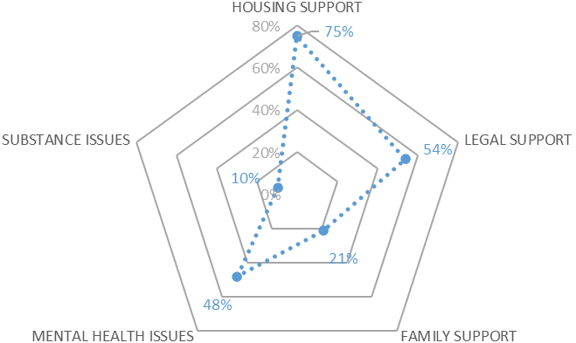

**COVENTRY HAVEN RESIDENTS SUPPORT NEEDS**

* The chart on the left shows the support needs of the residents in the Coventry Haven refuge in 2020-21.
* The information collected is different to that in Valley House so is not directly comparable.
* The data is based on the practitioner’s assessment and self-disclosure from the survivor.
* It shows that 49% of residents had mental health needs, 17% had physical health needs, 8% had alcohol needs, 4% had needs relating to offending, and 6% had needs relating to drugs.

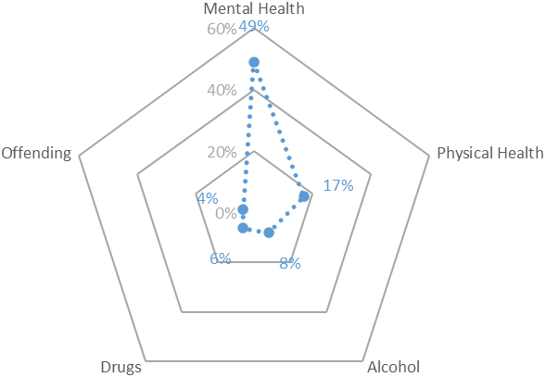

# RECOMMENDATIONS

**KEY FINDING 12 – ANXIETY AND TRAUMA**

* There is high prevalence of trauma and anxiety in survivors of domestic abuse, particularly at points of crisis such as in refuges. This need adds to the complexities of navigating through complex systems and processes such as the criminal justice system. Analysis of local refuge data aligns with national research regarding the support needs required within refuges.
* Feedback from practitioners and from residents was that it was hard to get trauma informed support while people were still in the refuge.

**IMPACT**

* The high prevalence of trauma and difficulties in getting appropriate support increases a range of risks including risk of harm to self, risk of returning to abusive partners, increased use of substances, and risks to children.

**RECOMMENDATION**

* Strengthen key worker confidence and skills in delivering trauma-informed practical and emotional support.
* Explore models of practice that enable refuges to become psychologically informed environments. (See Solace P.I.E. evaluation and PATH model).[[2]](https://www.solacewomensaid.org/sites/default/files/2018-05/Peace%20of%20Mind%20Summary%20Report.pdf)

“I have been on medication for 3 1/2 years and been crying out for support for my mental health as I became suicidal. I have another initial assessment in July despite many efforts to access services.”

Survivor, 35-44

Data from Coventry Haven for 2019/20 shows that 34% of those passing through the refuge were identified as having a potential mental health need.

**KEY FINDING 13 – CHILDREN AND YOUNG PEOPLE**

* There are currently limited resources relating to Children and Young Person workers in specialist domestic abuse accommodation.
* High numbers of children and young people are placed in refuge accommodation.

**IMPACT**

* The needs of children and young people cannot be addressed adequately within refuges unless service providers have resources to employ children’s workers.

**RECOMMENDATION**

* Review current best practice and research on meeting the needs of children in refuges and other safe accommodation and consider the allocation of additional resources to for specialist service providers
* Training for multi-agency professionals linked to families in refuge on best practice and the impacts of domestic abuse.

**KEY FINDING 14 – HOUSING SUPPORT**

* Analysis of local specialist accommodation data shows that families can be in refuge accommodation for up to 3 years, having a significant impact on their ability to ‘move-on’, heal, and recover from the abuse.
* Keyworkers expressed difficulties in getting consistent information and responses from housing staff and logistical challenges activating benefits and income for families, particularly where economic abuse and coercive control are present.

**IMPACT**

* Major impact on survivors’ psychological health, which can force some to return to abusers and create ‘bottle necks’ in the refuge system.

**RECOMMENDATION**

* Training for housing staff and linked professionals on the impact, risks and interventions for families affected by domestic violence
* Improve the consistency of information provided to families and support a problem-solving approach to housing families.
* Consider a systems review of the processes linked to safely housing families and supporting their needs.

“The system in place for victims and survivors of domestic abuse to find new housing is disgraceful. I was originally expected to move out of refuge into a private shared house where I would have no control over who I lived with, if they had violent issues or knew my abuser! It took a letter to my MP to secure my current home.”

Survivor, 25-34

HOUSING

# KEY FINDINGS

**MENTAL HEALTH**

* Analysis of local refuge/supported accommodation data shows needs in relation to mental health within specialist accommodation.
* Feedback from practitioners and from residents was that it was hard to get trauma informed support while people were still in the refuge.
* Feedback from practitioners was that there was a gap in trauma-informed work within the refuge.
* There was an opportunity for a refuge to become a psychologically safe environment.

**GENERAL NEEDS**

* Feedback from practitioners was that survivors face a lot of pressure while in a refuge and there are many competing factors that impact on a survivor’s emotional wellbeing, e.g. money, housing, immigration status, language, and children.



**CHILDREN AND YOUNG PEOPLE**

* There are currently limited resources relating to Children and Young Person workers in specialist domestic abuse accommodation.
* High numbers of children and young people are placed in refuge/ supported accommodation.
* Domestic abuse has a detrimental impact on the lives of children and young people. Children require specialist support to ensure their needs are met.



**HOUSING SUPPORT**

* Analysis of local refuge/ supported accommodation data shows that there is a support need in relation to housing. The housing process can be complicated for survivors of domestic abuse.



**HEALTH**

* Practitioners in specialist accommodation fed back that registering patients with health services can present challenges.

# RECOMMENDATION

**KEY FINDING 15 – ROLE OF KEYWORKER**

* The role of keyworkers in specialist services offering practical support, advice and guidance assisting families navigate through complex or unfamiliar systems such as housing, mental health, children’s services, benefits, and civil or criminal justice systems is crucial. Key workers are managing multiple competing demands in highly pressurized situations with limited resources and, during COVID-19, overwhelming need.

**IMPACT**

* Intense, consistent pressure on key workers leads to burnout and increases the risk to families of serious harm due to services being stretched beyond their capacity.

**RECOMMENDATION**

* Using our research on the self-identified needs of those in safe and emergency accommodation, increase awareness across the strategic partnership of the resource needs and stress points for frontline services.
* Training for housing professionals on the impact of domestic abuse and appropriate, safe interventions for families fleeing domestic violence.

**KEY FINDING 16 – HOUSING MANAGERS**

* Housing practitioners, including those in Housing Associations hold a lot of information that is useful in relation to identifying domestic abuse. They are not always consulted regarding this information.
* Housing officers are not always consulted early in a survivor’s journey (once domestic abuse has been identified by specialist services).

**IMPACT**

* Potential indicators/ signs of domestic abuse such as multiple lock changes, multiple repairs to properties are not investigated.
* Opportunities to identify practical issues that may delay housing bids may be missed.

**RECOMMENDATION**

* Consider adopting a Whole Housing Approach to raise awareness across the partnership of quality assurance standards and safe minimum practice[[3]](https://www.dahalliance.org.uk/).
* Training for housing officers and linked professionals on quality assurance standards, particularly in relation to vulnerability and intersectionality

**KEY FINDING 17 – HOUSING OFFICER**

* Fear of isolation, violence and harassment due to racism, stigmatisation and disability mean some survivors refuse housing offers and in doing so ‘start again’ in the bidding process. Survivors feel forced to accept offers which at times leaves them ‘between a rock and a hard place’.

**IMPACT**

* Local Authorities make one offer and survivors feel forced to accept the offer otherwise they delay their moving on. For vulnerable, minoritsed and racilaised families risks and impact are more severe.

**RECOMMENDATION**

* Using our research explore ways of increasing confidence and reducing risk for those families fearful of moving into accommodation or local areas due to the impact of vulnerability, racism, stigma and disability.

**KEY FINDING 18 – LIMITED HOUSING STOCK**

* Feedback from practitioner interviews were that large families are difficult to move on from refuges because there is limited 3–4-bedroom stock.

**IMPACT**

* Large families tend to go on housing waiting lists for a considerable amount of time. This impacts the availability of refuge places.
* Limited housing stock creates a bottle neck in emergency accommodation.

**RECOMMENDATION**

* This is potentially a national issue regarding availability of larger social housing stock and challenges for vulnerable individuals and families approaching private landlords. This requires strategic exploration.

**KEY FINDING 19 – PRIVATE HOUSING**

* Service users being directed towards private housing require a guarantor, which refuge residents tend not to be able to provide.

**IMPACT**

* This is a factor that could impact someone moving into new accommodation and as such could mean that a refuge space is being taken up for longer.

**RECOMMENDATION**

* Appropriate information and guidance should be made available for those moving into private rented properties.

“Housing is a massive issue in the city, and it is difficult to keep supporting families who could be waiting years for social housing. Also, if they look at private rentals, they need guarantors which we cannot provide.”

Family Hub Worker

**KEY FINDING 20 – FURNISHING PROPERTIES**

* Housing allowance does not cover the furnishing of properties. Currently, specialist domestic abuse providers use local contacts and privately sourced monies to support those who require furnishing/ white goods.

**IMPACT**

* This is a factor that could delay someone moving on from a refuge.

**RECOMMENDATION**

* Setting up of a fund to help with moving/furnishing costs.

COMMUNITY SERVICES

# KEY FINDINGS

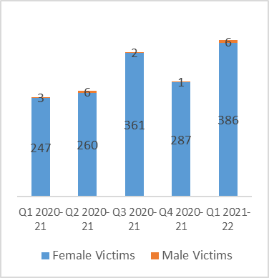

Referrals accepted by the community outreach service

**COMMUNITY OUTREACH**

* Panahghar and Coventry Haven are commissioned to provide services to those impacted by domestic abuse living in the community.
* Panahghar work with survivors from black and other ethnically minoritsed communities.
* The community outreach service works with those who are assessed as being at a standard and medium risk.
* The service offers practical and emotional support to survivors.
* Support is offered on a one-to-one basis.
* The service offers support in a number of different languages.

**HELPLINE**

* Panahghar and Coventry Haven run the Safe to Talk helpline in Coventry for those wanting information, advice and help in relation to domestic abuse.
* The helpline is a gateway to all domestic abuse services and is run by trained support workers.

**GROUP WORK**

* Group work sessions are offered for domestic abuse survivors.
* The group work covers:
  + Emotional support
  + Building relationships
  + An exploration of what constitutes domestic abuse.

From the *Q1 2021-22 Performance Report:*

*“We have successfully completed 9 generic Groupwork groups including evening, 2 were delivered in Polish speaking clients and one in French, with 44 SU’s attending. And held a further 3 groups a week, tailored for the BME community, one in the evening and two in the day, with a further 33 women attending.”*

**IDVA**

* Panahghar and Coventry Haven run an IDVA service working with women at high risk of domestic abuse.
* The information below shows the number of referrals to the IDVA service broken down by males and females.

**EARLY INTERVENTION PROJECT**

* The Early Intervention Project started running in April 2021. It is run jointly between Panahghar and Haven.
* The project places domestic abuse practitioners in Coventry Central Police Station to work with those who report crimes that are not immediately associated with domestic abuse.
* 3 workers (2 Haven, 1 Panahghar) are based in the police station to work with domestic abuse cases where there is a low and medium risk.
* BME women with a domestic abuse flag are directed to Panahghar.
* The information below shows the referrals to the Early Intervention Project for the first quarter that the project was running.

CHILDREN AND YOUNG PEOPLE

# KEY FINDINGS

**SPECIALIST DOMESTIC ABUSE SERVICE**

* The WISH Service works with children aged 5-18 who have been victims or who have witnessed domestic abuse and who are known to Children’s' Services. Children who are referred into the WISH Service have to be managed on a Children in Need Plan, or be known to Children’s Social Care as a Looked After Child.
* The most common age group that the WISH service works with are aged 5 – 11. Teenagers are less likely to engage in the service.
* Relate are flexible as to where their interventions can take place. Interventions can take place at:
  + Family Hubs
  + Schools
  + Social care offices
  + Online via Teams
* A pre and post evaluation is given to those children who engage in the service. This includes a discussion of safety. The evaluation checks on the child’s relationships with their parents. The evaluation asks questions about anything else the child wants or needs.
* WISH practitioners provide reporting to Child Protection Case Conferences and Reviews. Legal reports are provided where necessary. Practitioners also share disclosures with relevant agencies.

# RECOMMENDATION

**KEY FINDING 21 – SPECIALIST SUPPORT**

* Practitioners fed back that there is a lot of expectations on schools to complete counselling and one-to-one work with children and young people. Schools may not have the time or resources to meet all these needs.
* The WISH Service works with children aged 5-18 who have been victims or who have witnessed domestic abuse and who are known to Children’s' Services.

**IMPACT**

* School environments provide key opportunities to display useful information about domestic abuse (to parents, children and young people) thus enabling access to specialist services and advice, particularly for those families with no Children Services involvement.
* Schools can be a key referral point to safeguarding services, community support and specialist support, particularly for vulnerable, racialised and minoritized families.

**RECOMMENDATION**

* There is a need for a service that offers access to those young people who have been impacted by domestic abuse but who do not have Children’s' Services involvement.
* Explore the concept of a Whole School Approach as a strategy to implement primary prevention work with children and young people.
* Training on the dynamics of domestic violence and risk identification for teachers, volunteers and linked practitioners working directly with children and young people in school environments.
* Work with practitioners working with children under 5 to ensure that they are confident in identifying those affected by domestic abuse and are aware of the appropriate pathways to services.

“Schools are often left to try and provide support for children and are not supported with is by DV specific services.”

Coventry City Council, Early Help

“Support needs to be available for all children to access, children within early help are not able to access the WISH support.”

Family Hub Worker

ETHNIC MINORITIES



# KEY FINDINGS



**TRANSLATORS**

* Survivors who have NRPF can often have needs relating to translators.
* Translation services can be costly.

**NO RECOURSE TO PUBLIC FUNDS (NRPF)**

* In 2020-21 the refuge providers in Coventry supported the following numbers of residents who were recorded as having No Recourse to Public Funds:
  + Valley House – (2020-21) - 18 out of 271 (7%)
  + Coventry Haven (April to June 2021) – 6 out of 14 (43%)
  + Panahghar – (2020-21) 33 out of 48 (69%)

**ISSUES LINKED WITH MIGRATION AND GENDER INEQUALITIES**

* Cultural and community pressures may make it more difficult for women for escape the abuser/s. Others are trafficked or forced into marriage.
* Difficultly for women accessing services in which staff do not speak their language.
* Insecure immigration status can lead to immigration abuse by perpetrators
* Fear of children being abducted
* Fear of statutory agencies

# RECOMMENDATIONS

**KEY FINDING 22 – NO RECOURSE TO PUBLIC FUNDS**

* In 2020-21 the refuge providers in Coventry supported the following numbers of residents who were recorded as having No Recourse to Public Funds:
  + Valley House – (2020-21) - 18 out of 271 (7%)
  + Coventry Haven (April to June 2021) – 6 out of 14 (43%)
  + Panahghar – (2020-21) 33 out of 48 (69%)
* Practitioners working with those who have NRPF need to have a specialist knowledge of immigration law.
* Practitioners from Panahghar stated that working with those who have NRPF can require twice as much time as those who can access benefits.

**IMPACT**

* There are many barriers to accessing services for this population which also greatly heightens risk, such as language barriers and a lack of funded translation or screened interpreter services. Staff who are not multilingual are forced to use Google Translate to onboard residents and communicate complex processes and systems.

**RECOMMENDATION**

* Further explore the particular needs and challenges for this population in partnership with specialist services to identify practical solutions.

**KEY FINDING 23 – TRANSLATORS**

* Survivors who have NRPF can often have needs relating to translators.
* Specialist services have staff who can speak a range of languages.
* Translations can also be obtained via translation services and online software however these are not always accurate.

**IMPACT**

* Translator services have to be available in a range of different languages.
* Translation services can be costly.
* Survivors are not able to articulate their needs appropriately or be understood.

**RECOMMENDATION**

* Additional resources to be provided in this area.

MEN

# KEY FINDINGS

**SERVICE PROVISION**

* Valley House, the local authority commissioned refuge/ safe accommodation provider can provide support to male survivors of domestic abuse.
* Males are housed in the stand-alone properties run by Valley House as the refuges and clusters of supported housing are single gender properties.
* The referral process for males works the same as females. Feedback from practitioners was that the referrals for males tend to be urgent in nature.
* Males are given a different risk assessment but have the same access to advocacy and support as female residents.

**COVID-19**

* National data from Men’s Advice Line, indicated that phone, email, and web contacts increased by 57% in 2020-21 compared to 2019-20.



**SURVIVOR SURVEY RESPONSES**

* In the survivor survey run as part of this needs assessment, there were 7 (10%) responses from male survivors.
* The number was too low to draw any real conclusions from, however the free text did allow some comments to be made.
* Of the male respondents, 3 were White British and 3 were of Asian backgrounds, 1 preferred not to say.
* One respondent said that there was a lack of accommodation for BME groups.
* One respondent cited the lack of male only accommodation as a reason for not moving to specialist accommodation.
* One respondent stated that court proceedings helped them remain in their own home.

“My partner was bailed not to come back to the house, & then I got a non-molestation order preventing her from returning to my home.”

Survivor, 55-64

**PRACTITIONER SURVEY RESPONSES**

* In the practitioner survey, respondents could leave some free text comments. One respondent commented on the issue of communal refuges not able to accept male survivors.

“Refuges often will not take single men or they are female only spaces.”

Coventry City Council, Programme Manager