STRATEGIC PLAN
Interim 1 Year Plan
April 2021 - March 2022
Executive Summary
Please note due to COVID-19 the timetable to develop our new 3 Year Strategic Plan during 2020-2021 was severely disrupted. We have been unable to hold meaningful discussions with our key stakeholders and as such have developed a 1 Year Interim Plan, utilising the strategic objectives and delivery plan that have guided our 2018-2021 Strategic Plan.
Valley House is a Coventry based charity providing services across Coventry and Warwickshire. We have a dedicated team of over 50 staff and 12 volunteers. We provide specialist, tailored services to over 500 service users a year. We aim to support individuals and families to gain the confidence to respond confidently to the challenges of life.
We Provide:
- Supported accommodation to individuals and families escaping domestic abuse
- Supported accommodation to young parents that are unable to live at home or independently
- Community support for young parents living in the community
- Community support for individuals that have low level mental health needs
- A nursery open to the local community, providing Government funded and fee paying places
- Student placement opportunities for both trainee Social Workers and trainee counsellors
All of our services work towards achieving sustainable outcomes that we believe support positive change.

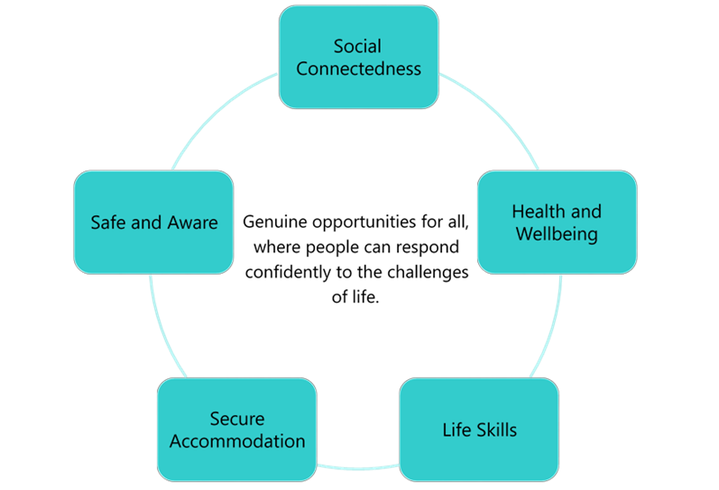

Our Background
Back in the late 1970s, the community of Stoke Heath in Coventry saw that some young people from the local area were struggling and getting into trouble.

A group of volunteers came together and came up with the idea that with access to emergency housing, these young people could be supported to make a change. They approached the local council for help and were given a property – 84 Valley Road – and Valley House was born.

Since its beginnings in 1977, Valley House has grown from a single house to an entire organisation offering a range of accommodation and community based services for vulnerable individuals and families across Coventry and Warwickshire.

Vision/Mission/Values
Throughout our 40-year history we have remained true to our original Vision, Mission and Values. With the deepening divide between individuals and communities they remain as relevant today as they did when Valley House was created.
Vision
Genuine opportunities for all, where people can respond confidently to the challenges of life

Mission
To work alongside people to take control of their lives and create their own futures

Values
Respectful
We will seek to understand those we work with and value them. We welcome people of all backgrounds and life experiences.
Focused
Those who use our services drive what we do. We work to deliver quality results and also do what we say we will do.
Innovative
We will continually improve what we do by adopting new ideas and partnerships and by adapting as the world around us changes

Strategic Objectives
Valley House identified 4 Strategic Objectives that set out a clear direction of travel for 2018-2021. These Strategic Objectives were underpinned by our Vision, Mission and Values and are aligned to our Theory of Change. Due to COVID-19 impacting our ability to develop our new 3 Year Plan, we have developed a 1 Year Interim Plan, utilising these strategic objectives and accompanying delivery plan.
- Service users experience relevant, innovative services
- We enable service users to develop insight, skills and confidence to explore and find solutions to the issues they face
- We will have the right systems, skills, governance and funding model to forge a sustainable future
- Valley House will endeavour to develop a reputation as a leading provider of services

STRATEGIC OBJECTIVE 1
Service users experience relevant, innovative services
- We will review all current service delivery models with staff, service users and stakeholders to ensure their relevance and that they are truly innovative
- We will redesign services that fulfil identified need and in line with our Vision – fitting in with our Theory of Change
- We will actively pilot interventions where we have limited robust evidence in order to test – allocating our own resources and sourcing external funding where possible
- We will actively involve service users in the design and delivery of our interventions
- We will develop a Valley House approach to service user involvement, building on evidence of “what works”. This will acknowledge/incorporate/include all service users. This will recognise the importance of difference/diversity
- We will create learning and development opportunities for our service users, building on their strengths/utilising an asset based approach
- We will actively seek out partnership working opportunities that enable us to offer effective packages of support

STRATEGIC OBJECTIVE 2
We enable service users to develop insight, skills and confidence to explore and find solutions to the issues they face
- We will have effective feedback mechanisms and progression measurements in place to ensure service users are developing insight, skills and confidence to explore and find solutions to the issues they face
- We will have effective mechanisms in place to collect/analyse feedback from external stakeholders that evidences that our interventions support service users to develop insight, skills and confidence to explore and find solutions to the issues they face
STRATEGIC OBJECTIVE 3
We will have the right systems, skills, governance and funding model to forge a sustainable future
- Our IT system will be effective and flexible, allowing us to fully meet our needs
- Our governance arrangements will reflect best practice
- Our funding models will recognise the need to decrease our dependency on Government contracts, creating greater flexibility to meet service user need
STRATEGIC OBJECTIVE 4
Valley House will endeavour to develop a reputation as a leading provider of services
- We will clearly define and articulate the Valley House Services offer
- We will map local provision to identify gaps that can link into our offer
- We will raise the profile of Valley House with external stakeholders
- We will strive to be the “go to” service in our sector

Strategic Plan 2021-2022
Delivery Plan

OBJECTIVE 1:
Service users experience relevant, innovative services
ORGANISATIONAL TARGET | YEAR 1
1.1 We will review all current service delivery models with staff, service users and stakeholders to ensure their relevance and that they are truly innovative | As part of the Staff Survey we will measure satisfaction with involvement in service re-design
 | As part of Service User Involvement Implementation Plan we will measure satisfaction with involvement in service redesign
 | As part of Stakeholder Survey we will include a question in relation to our responsiveness to suggested changes
1.2 We will redesign services that fulfil identified need and in line with our Vision – fitting in with our Theory of Change | Review progress made against individual service action plans and where appropriate create action plans
1.3 We will actively pilot interventions where we have limited robust evidence in order to test – allocating our own resources and sourcing external funding where possible | Review actual spend of designated internal fund against expected spend and the benefits of this in terms of expected internally set outputs and outcomes
 | Designate an internal fund to support the re-design and piloting of approaches currently not funded as well as sourcing external funding where possible
1.4 We will actively involve service users in the design and delivery of our interventions | Review the Service User Involvement Implementation Plan and performance against KPI’s
1.5 We will develop a Valley House approach to service user involvement, building on evidence of “what works”. This will acknowledge, incorporate, include all service users. This will recognise the importance of difference/diversity | Review the Service User Involvement Implementation Plan and performance against KPI’s
1.6 We will create learning and development opportunities for our service users, building on their strengths/utilising an asset based approach | Review the Organisational Service User Learning and Development Plan, based on internal feedback, reviewing any new research in relation to what learning and development opportunities would support our service users
1.7 We will actively seek out partnership working opportunities that enable us to offer effective packages of support | Review and update as appropriate list of key strategic and operational partners identified in previous years
 | Evaluate partnership working, including feedback internally from staff and service users as well as identified partners
 | Share what has worked internally in relation to effective partnership working across all services to embed good practice
 | Clearly identify any barriers to effective partnership working encountered, and action plan to mitigate these going forward

OBJECTIVE 2:
We enable service users to develop insight, skills and confidence to explore and find solutions to the issues they face
ORGANISATIONAL TARGET | YEAR 1
2.1 We will have effective feedback mechanisms and progression measurements in place to ensure service users are developing insight, skills and confidence to explore and find solutions to the issues they face | Review service user feedback usage against KPI’s and create organisational and/or service specific Quality Improvement Plan(s) as needed
2.2 We will have effective mechanisms in place to collect/analyse feedback from external stakeholders that evidences that our interventions support service users to develop insight, skills and confidence to explore and find solutions to the issues they face | Distribute Stakeholder Survey that will allow us to analyse whether our interventions support service users to develop insight, skills and confidence to explore and find solutions to the issues they face

OBJECTIVE 3:
We will have the right systems, skills, governance and funding models to forge a sustainable future
ORGANISATIONAL TARGET | YEAR 1
3.1 Our IT system will be effective and flexible, allowing us to fully meet our needs | Survey staff in relation to the effectiveness of the IT system and equipment
 | Where feasible, we will look to implement further changes as identified through the staff survey
3.2 Our governance arrangements will reflect best practice | Review the Good Governance action plan and performance against KPI’s
 | Where appropriate, create a new Good Governance action plan with timelines and KPI’s that can be monitored
3.3 Our funding models will recognise the need to decrease our dependency on Government contracts, creating greater flexibility to meet service user need | Continue exploring potential funding models that reflect external funding opportunities
 | Evaluate success of business plans and lessons learnt to inform improvements needed
 | Create new business plans that reflect viable external funding opportunities
 | Prioritise and implement business plans
3.4 We will endeavour to achieve an overall surplus from our activities to ensure we continue to be financially sustainable | Closely monitor spend and identify cost savings to create a surplus

OBJECTIVE 4:
Valley House will endeavour to develop a reputation as a leading provider of services
ORGANISATIONAL TARGET | YEAR 1
4.1 We will clearly define and articulate the Valley House Services offer | Review website and leaflets
 | Compare our social media presence year on year to ensure an increase
4.2 We will map local provision to identify gaps that can link into our offer | We will actively market our offer which meets unmet need, to identified funders and commissioners
4.3 We will raise the profile of Valley House with external stakeholders | We will evaluate the success of our Communications Plan and lessons learnt to inform improvements needed, and adapt as needed
4.4 We will strive to be the “go to” service in our sector | Where we have been successful or unsuccessful in funding applications, we will request feedback as to why – in order to establish our standing within the sector

